**PROJECT REPORT**

**on**

**APP on GEHU**

**(CSE IV Semester Mini project PCS-604)**

**2020-2021**



**Submitted to: Submitted by:**

Ms. Rishika Yadav Saurabh Thapliyal

(CC-CSE-N-IV-Sem) Roll. No.: 49

**Guided by:** CSE-I-IV-Sem

Ms.Rishika Yadav Session: 2021-2022

(Resource Person)

**DEPARTMENT OF COMPUTER SCIENCE AND INFORMATION TECHNOLOGY**

**GRAPHIC ERA HILL UNVERSITY, DEHRADUN**

**CERTIFICATE**

### Certified that Mr. Saurabh Thapliyal (University Roll No.- 2018712) has developed mini project on “High Quality App for GEHU” for the CS IV Semester Mini Project in Graphic Era Hill University, Dehradun. The project carried out by Students is their own work as best of my knowledge.

Date: 11/07/22

**ACKNOWLEDGMENT**

I would like to thank particularly our project Co-ordinator MS. Rishika Yadav for her support and encouragement throughout the completion of this project and having faith in us. I also like wish to thank my parents for their continuing support and encouragement. I also wish to thank them for providing us with the opportunity to reach this far in our studies.

At last but not the least We greatly indebted to all other persons who directly or indirectly helped us during this work.

**Saurabh Thapliyal**

**Class Roll No.- 49**

**University Roll No.-2018712**

**CSE-I-IV-Sem**

**Session: 2021-2022**

**GEHU, Dehradun**

**TABLE OF CONTENTS**

**1. About Flutter**

1.1 About Flutter

1.2 Why Flutter

**2. Aim of the project**

2.1 About the project

2.1 Technology used

**3. SNAPSHOT OF THE PROJECT**

3.1 Sign In/Log In Options

3.2 Log In Window

3.3 Sign In Window

3.4 Welcome Screen of the App

3.5 Drawer Menu

3.6 Admission Window

3.7 About Screen

3.8 Academics Screen

3.9 Contact Us Screen

3.10 Official Website Link Screen

3.11 Developer Card of the Student

**4. CODE SEGMANT OF THE PROJECT**

4.1 Developer Card of the Student

4.2 Log In Window

4.3 Sign In Window

4.4 Welcome Screen of the App

4.5 Admission Window

4.6 About Screen

4.7 Academics Screen

4.8 Contact Us Screen

4.9 Official Website Link Screen

**5. CONCLUSION 29**

4.1 SUMMARY 29

4.2 FUTURE WORKS 30

**ABOUT FLUTTER**

let’s try to explore the definition of Flutter. What is Flutter and why are we talking about it today? Flutter is an open-source technology delivered by Google to develop mobile, web, and desktop applications with a single codebase that can be used for multiple platforms.

The technology is a goldmine for cross-platform app development because it is not a library or framework that is used in addition to other technologies, but rather a UI software development kit (SDK).

A library refers to pieces of code that can be utilized in an app to perform a certain function, whereas a framework acts as a structure to the future app by providing you with tools to complete the architecture.

An SDK is a set of various tools, including libraries, frameworks, documentation, APIs, etc., sufficient enough to build a fully functioning application.

Flutter is often compared with other languages and frameworks, such as React Native, Xamarin, and even Kotlin. You can read more about native app development with Kotlin vs. cross-platform app creation with Flutter here.

Besides that, you can learn about React Native vs. Flutter for platform-independent app development here.

**Why Flutter?**

What is Flutter app development and how will it help you achieve your business goals? In this section, we will take a closer look at the benefits of Flutter and try to establish the reasons why so many companies decide to use this technology for their cross-platform app development.

### 1. Cross-platform App Development

### 2. It’s Fast, Fast, Fast

### 3. Support for Older Devices

### 4. Top-notch user experience

### 5. Cost efficiency

### 6. Google guaranteed

**ABOUT THE APP**

This app is about the app version of the official website which we often see as name of gehu.ac.in ,This whole app resolves around the Techstack name flutter which is recently develop my google developing team ,this techstack is inspired from many Object Oriented Programming like java,c++,python etc.so the individual like me who has prior knowledge of coding can easily understand the feature and functionality of the flutter ,as I disscued above Flutter is open source UI sdk ,which works on the dart programming language .

Aim: My aim is to create a informative app Regarding the university,which consists important details like facilities,faculties about the campus etc.In will a major project as features like student login,faculties login and placement information will added soon.

**Technology Used**

1)Android Studio

2) Android API 31 Platform (2)

3)Front End : Dart Programming language

4)Flutter framework

5) Backend : FireBase

**Snapshot of the project**

**Sign In/Log In Options**



**Log In**

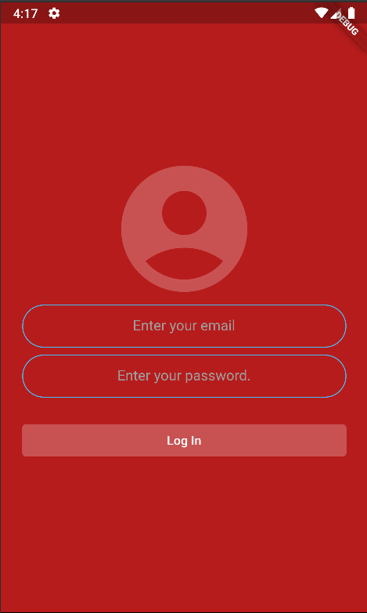

**Sign In**

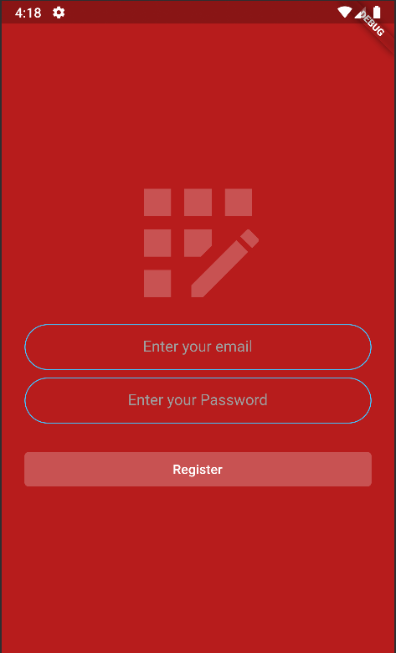

**Welcome Screen**

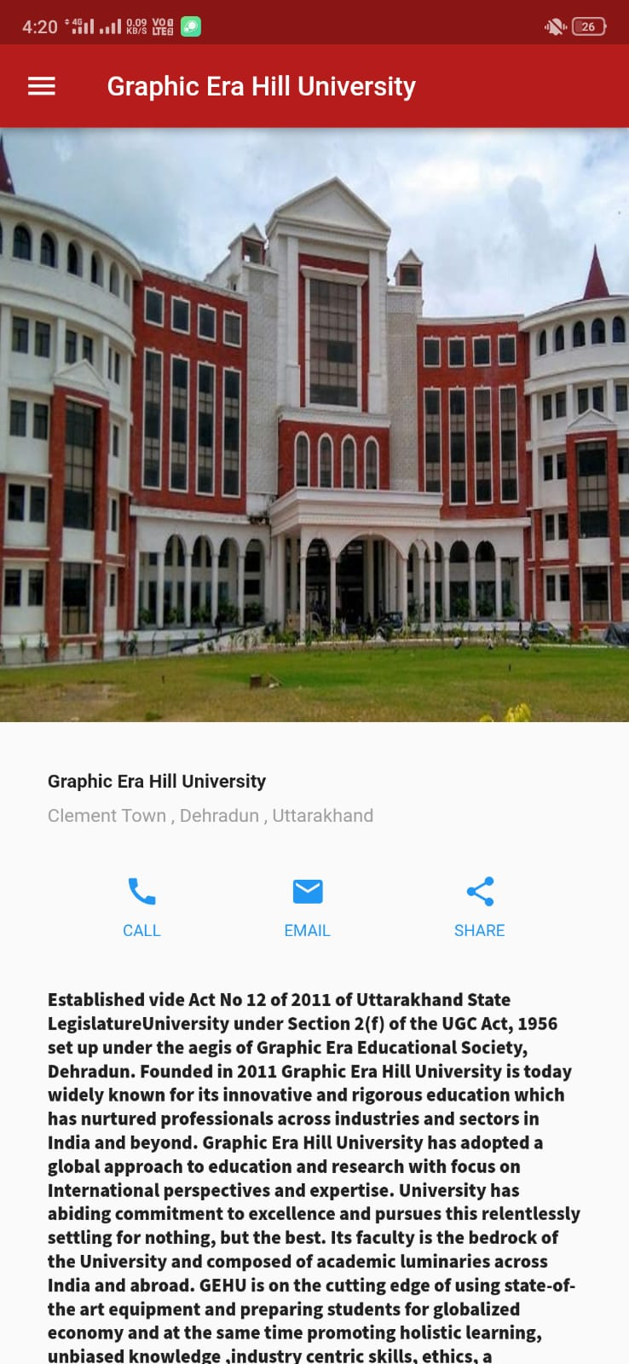

**Drawer Menu**

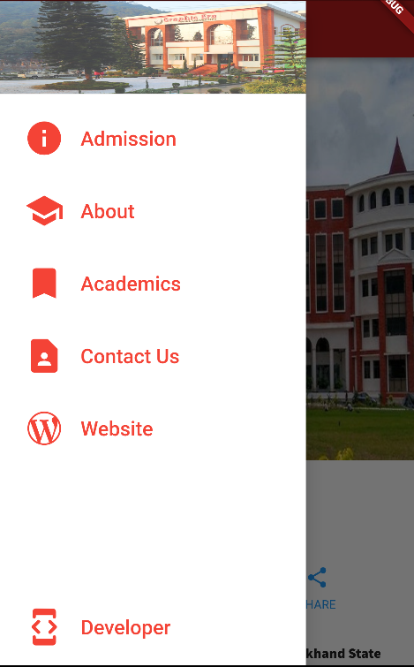

**Admission Window**

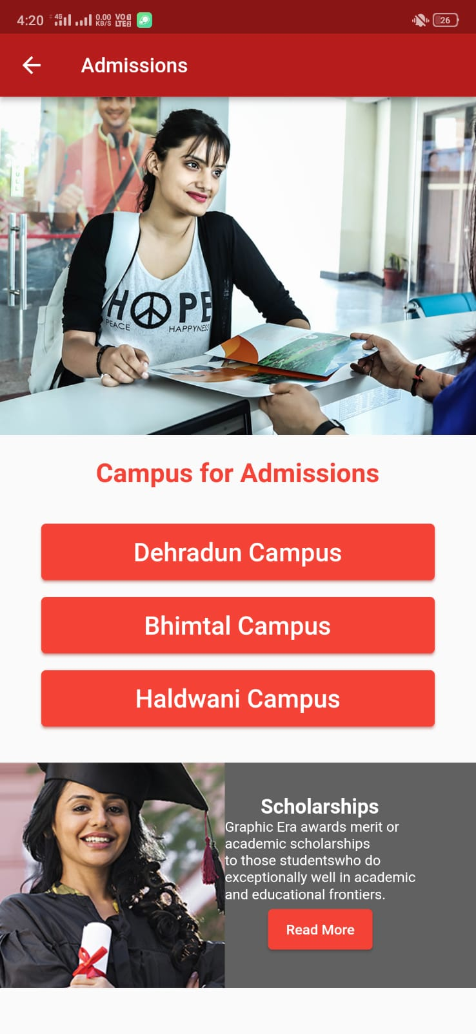

**About Window**

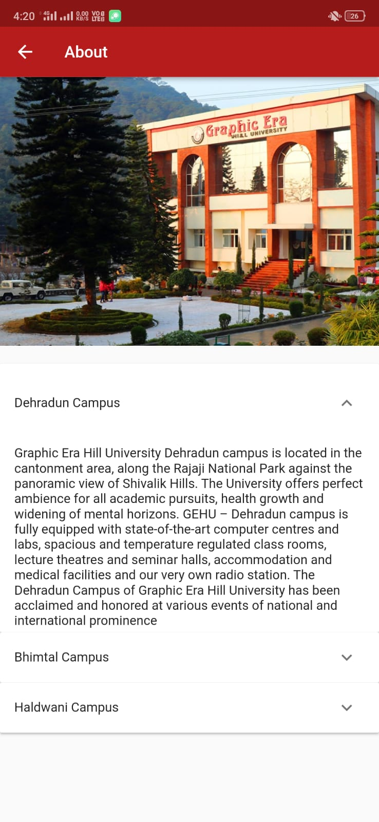

**Academics Window**

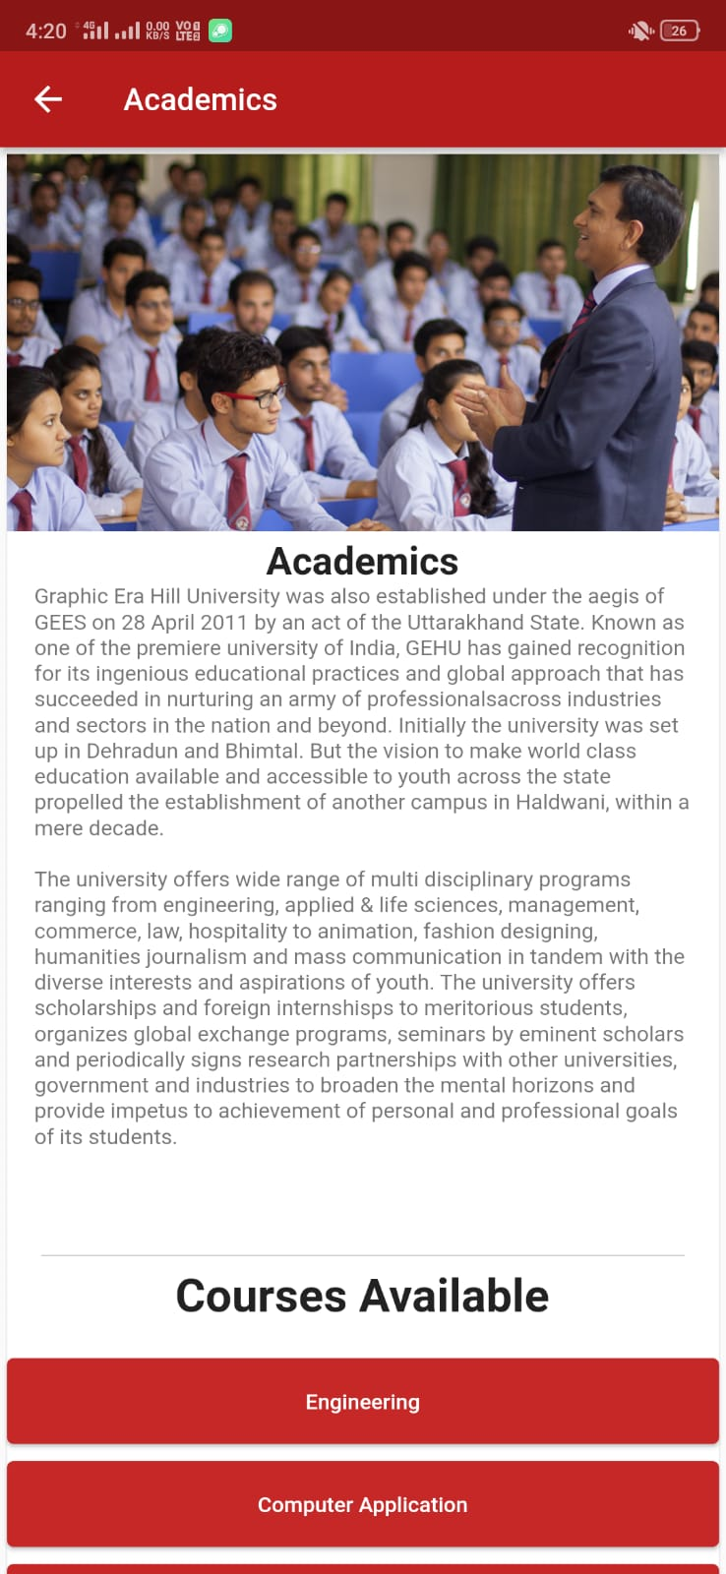

**Contact Us**

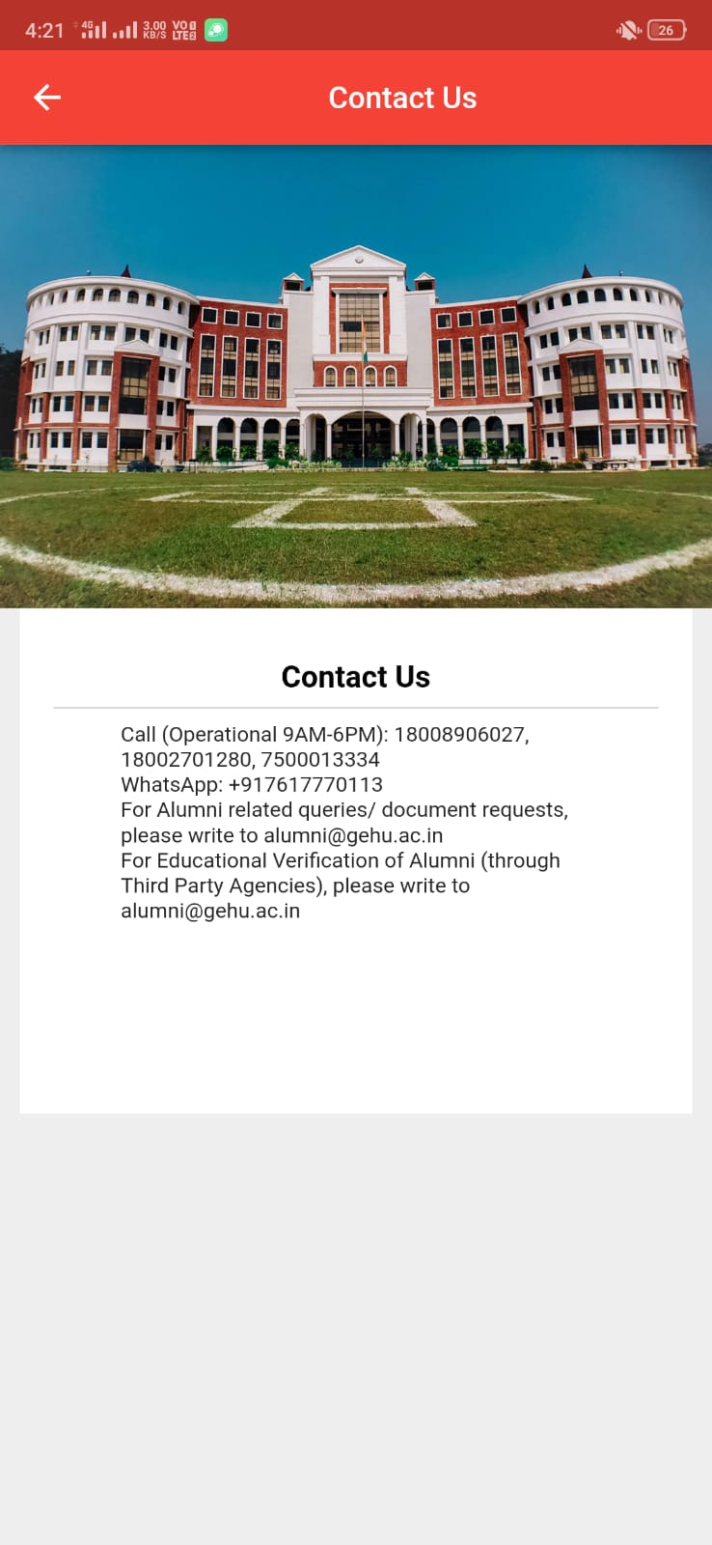

**Official Website link**

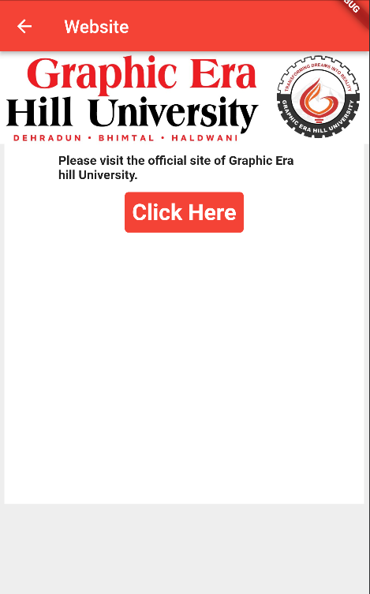

**Information Card of the student**

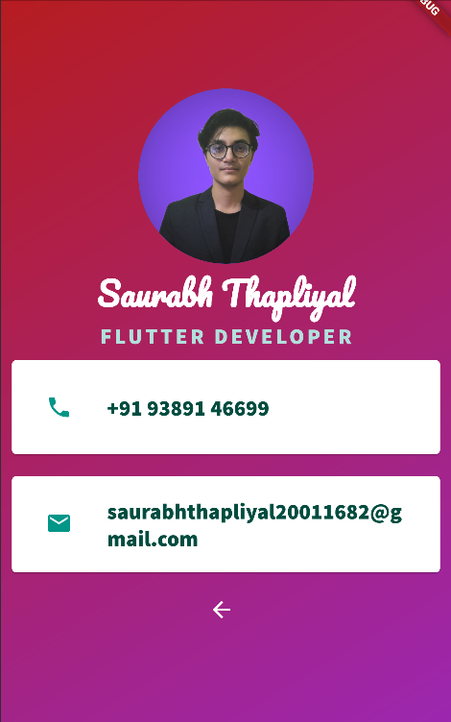

**Code Segment of the app**

Given below the fragement of the code of the app

This part consists of the Login Page through Email

**Code Part 1:**

Given below the fragement of the code of the app,This part consists of the Login Page through Email which works with the fire base in the backend to check if the user is registered

//@dart=2.9  
import 'package:firebase_auth/firebase_auth.dart';  
import 'package:modal_progress_hud/modal_progress_hud.dart';  
import 'package:practice/login.dart';  
import 'package:flutter/material.dart';  
  
//code for designing the UI of our text field where the user writes his email id or password  
  
const kTextFieldDecoration = InputDecoration(  
 hintText: 'Enter a value',  
 hintStyle: TextStyle(color: Colors.*grey*),  
 contentPadding: EdgeInsets.symmetric(vertical: 10.0, horizontal: 20.0),  
 border: OutlineInputBorder(  
 borderRadius: BorderRadius.all(Radius.circular(32.0)),  
 ),  
 enabledBorder: OutlineInputBorder(  
 borderSide: BorderSide(color: Colors.*lightBlueAccent*, width: 1.0),  
 borderRadius: BorderRadius.all(Radius.circular(32.0)),  
 ),  
 focusedBorder: OutlineInputBorder(  
 borderSide: BorderSide(color: Colors.*lightBlueAccent*, width: 2.0),  
 borderRadius: BorderRadius.all(Radius.circular(32.0)),  
 ));  
  
class LoginScreen extends StatefulWidget {  
 @override  
 _LoginScreenState createState() => _LoginScreenState();  
}  
  
final _auth = FirebaseAuth.*instance*;  
  
class _LoginScreenState extends State<LoginScreen> {  
 String email;  
 String password;  
 bool showSpinner = false;  
 @override  
 Widget build(BuildContext context) {  
 return Container(  
 child: Scaffold(  
 backgroundColor: Colors.*red*.shade900,  
 body: ModalProgressHUD(  
 inAsyncCall: showSpinner,  
 child: Padding(  
 padding: EdgeInsets.symmetric(horizontal: 24.0),  
 child: Column(  
 mainAxisAlignment: MainAxisAlignment.center,  
 crossAxisAlignment: CrossAxisAlignment.stretch,  
 children: <Widget>[  
 const Icon(  
 Icons.*account_circle_rounded*,  
 size: 170.0,  
 color: Colors.*white24*,  
 ),  
 TextField(  
 cursorColor: Colors.*white*,  
 keyboardType: TextInputType.*emailAddress*,  
 textAlign: TextAlign.center,  
 onChanged: (value) {  
 email = value;  
 //Do something with the user input.  
 },  
 decoration: kTextFieldDecoration.copyWith(  
 hintText: 'Enter your email',  
 )),  
 const SizedBox(  
 height: 8.0,  
 ),  
 TextField(  
 obscureText: true,  
 textAlign: TextAlign.center,  
 onChanged: (value) {  
 password = value;  
 //Do something with the user input.  
 },  
 decoration: kTextFieldDecoration.copyWith(  
 hintText: 'Enter your password.')),  
 const SizedBox(  
 height: 24.0,  
 ),  
 TextButton(  
 style: TextButton.*styleFrom*(  
 primary: Colors.*white*,  
 backgroundColor: Colors.*white24*,  
 ),  
 child: const Text('Log In'),  
 onPressed: () async {  
 setState(() {  
 showSpinner = true;  
 });  
 try {  
 final user = await _auth.signInWithEmailAndPassword(  
 email: email, password: password);  
 if (user != null) {  
 Navigator.*push*(  
 context,  
 MaterialPageRoute(builder: (context) => HomePage()),  
 );  
 }  
 } catch (e) {  
 print(e);  
 }  
 setState(() {  
 showSpinner = false;  
 });  
 }),  
 ],  
 ),  
 ),  
 ),  
 ),  
 );  
 }  
}

**Code Part 2 :**

**Another segement of the app is the Welcome Screen of the App Which contains a app Drawer which is linked to all other app windows of the app**

void main() {  
 runApp(const MaterialApp(  
 title: 'Graphic Era Hill University',  
 home: HomePage(),  
 ));  
}  
  
class HomePage extends StatelessWidget {  
 const HomePage({super.key});  
  
 TextButton put({required IconData i, required String s}) {  
 return TextButton(  
 child: ListTile(  
 leading: Icon(  
 i,  
 size: 50.0,  
 color: Colors.*white*,  
 ),  
 title: Text(  
 s,  
 style: const TextStyle(  
 fontSize: 25.0,  
 color: Colors.*white*,  
 ),  
 ),  
 ),  
 onPressed: () {},  
 );  
 }  
  
 @override  
 Widget build(BuildContext context) {  
 Color color = Theme.*of*(context).primaryColor;  
  
 Widget titleSection = Container(  
 padding: const EdgeInsets.all(32),  
 child: Row(  
 children: [  
 Expanded(  
 /*1*/  
 child: Column(  
 crossAxisAlignment: CrossAxisAlignment.start,  
 children: [  
 /*2*/  
 Container(  
 padding: const EdgeInsets.only(bottom: 8),  
 child: const Text(  
 'Graphic Era Hill University',  
 style: TextStyle(  
 fontWeight: FontWeight.*bold*,  
 ),  
 ),  
 ),  
 Text(  
 'Clement Town , Dehradun , Uttarakhand',  
 style: TextStyle(  
 color: Colors.*grey*[500],  
 ),  
 ),  
 ],  
 ),  
 ),  
 ],  
 ),  
 );  
 Column _buildButtonColumn(Color color, IconData icon, String label) {  
 return Column(  
 mainAxisSize: MainAxisSize.min,  
 mainAxisAlignment: MainAxisAlignment.center,  
 children: [  
 Icon(icon, color: color),  
 Container(  
 margin: const EdgeInsets.only(top: 8),  
 child: Text(  
 label,  
 style: TextStyle(  
 fontSize: 12,  
 fontWeight: FontWeight.*w400*,  
 color: color,  
 ),  
 ),  
 ),  
 ],  
 );  
 }  
  
 Widget buttonSection = Row(  
 mainAxisAlignment: MainAxisAlignment.spaceEvenly,  
 children: [  
 _buildButtonColumn(color, Icons.*call*, 'CALL'),  
 _buildButtonColumn(color, Icons.*email*, 'EMAIL'),  
 _buildButtonColumn(color, Icons.*share*, 'SHARE'),  
 ],  
 );

**Code Part 3 :**

**Another segement of the app is Sign in Page Which works with the FireBase in Backend to register and Authenticate the user after that it redirects the user to the Log in Screen**

const kTextFieldDecoration = InputDecoration(  
 hintText: 'Enter a value',  
 hintStyle: TextStyle(color: Colors.*grey*),  
 contentPadding: EdgeInsets.symmetric(vertical: 10.0, horizontal: 20.0),  
 border: OutlineInputBorder(  
 borderRadius: BorderRadius.all(Radius.circular(32.0)),  
 ),  
 enabledBorder: OutlineInputBorder(  
 borderSide: BorderSide(color: Colors.*lightBlueAccent*, width: 1.0),  
 borderRadius: BorderRadius.all(Radius.circular(32.0)),  
 ),  
 focusedBorder: OutlineInputBorder(  
 borderSide: BorderSide(color: Colors.*lightBlueAccent*, width: 2.0),  
 borderRadius: BorderRadius.all(Radius.circular(32.0)),  
 ),  
);  
  
class RegistrationScreen extends StatefulWidget {  
 const RegistrationScreen({Key key}) : super(key: key);  
  
 @override  
 _RegistrationScreenState createState() => _RegistrationScreenState();  
}  
  
class _RegistrationScreenState extends State<RegistrationScreen> {  
 final _auth = FirebaseAuth.*instance*;  
 String email;  
 String password;  
 bool showSpinner = false;  
 @override  
 Widget build(BuildContext context) {  
 return Container(  
 child: Scaffold(  
 backgroundColor: Colors.*red*.shade900,  
 body: ModalProgressHUD(  
 inAsyncCall: showSpinner,  
 child: Padding(  
 padding: EdgeInsets.symmetric(horizontal: 24.0),  
 child: Column(  
 mainAxisAlignment: MainAxisAlignment.center,  
 crossAxisAlignment: CrossAxisAlignment.stretch,  
 children: <Widget>[  
 const Icon(  
 Icons.*app_registration*,  
 size: 170.0,  
 color: Colors.*white24*,  
 ),  
 TextField(  
 keyboardType: TextInputType.*emailAddress*,  
 textAlign: TextAlign.center,  
 onChanged: (value) {  
 email = value;  
 },  
 decoration: kTextFieldDecoration.copyWith(  
 hintText: 'Enter your email')),  
 const SizedBox(  
 height: 8.0,  
 ),  
 TextField(  
 obscureText: true,  
 textAlign: TextAlign.center,  
 onChanged: (value) {  
 password = value;  
 },  
 decoration: kTextFieldDecoration.copyWith(  
 hintText: 'Enter your Password')),  
 const SizedBox(  
 height: 24.0,  
 ),  
 TextButton(  
 style: TextButton.*styleFrom*(  
 primary: Colors.*white*,  
 backgroundColor: Colors.*white24*,  
 ),  
 child: const Text('Register'),  
 onPressed: () async {  
 setState(() {  
 showSpinner = true;  
 });  
 try {  
 final newUser =  
 await _auth.createUserWithEmailAndPassword(  
 email: email, password: password);  
 if (newUser != null) {  
 Navigator.*push*(  
 context,  
 MaterialPageRoute(  
 builder: (context) => LoginScreen()),  
 );  
 }  
 } catch (e) {  
 print(e);  
 }  
 setState(() {  
 showSpinner = false;  
 });  
 },  
 )  
 ],  
 ),  
 ),  
 ),  
 ),  
 );  
 }  
}

**Code Part 4 :**

**This Segment contains the Developer Information**

import 'package:flutter/material.dart';  
  
class ProfilePage extends StatelessWidget {  
 const ProfilePage({super.key});  
 @override  
 Widget build(BuildContext context) {  
 return Container(  
 decoration: BoxDecoration(  
 gradient: LinearGradient(  
 begin: Alignment.*topLeft*,  
 end: Alignment.*bottomRight*,  
 colors: [Colors.*red*.shade900, Colors.*purple*])),  
 child: Scaffold(  
 backgroundColor: Colors.*transparent*,  
 body: SafeArea(  
 child: Column(  
 mainAxisAlignment: MainAxisAlignment.center,  
 children: <Widget>[  
 const CircleAvatar(  
 backgroundImage: AssetImage('images/me.png'),  
 radius: 90.0,  
 ),  
 const Text(  
 'Saurabh Thapliyal',  
 style: TextStyle(  
 fontFamily: 'Pacifico',  
 fontSize: 30.0,  
 color: Colors.*white*,  
 fontWeight: FontWeight.*bold*,  
 ),  
 ),  
 Text(  
 'FLUTTER DEVELOPER',  
 style: TextStyle(  
 fontFamily: 'SourceSansPro',  
 color: Colors.*teal*.shade100,  
 fontSize: 20.0,  
 letterSpacing: 2.5,  
 fontWeight: FontWeight.*bold*,  
 ),  
 ),  
 Card(  
 color: Colors.*white*,  
 margin: const EdgeInsets.symmetric(  
 vertical: 10.0,  
 horizontal: 10.0,  
 ),  
 child: Padding(  
 padding: const EdgeInsets.all(15.0),  
 child: ListTile(  
 leading: const Icon(  
 Icons.*phone*,  
 color: Colors.*teal*,  
 ),  
 title: Text(  
 '+91 93891 46699',  
 style: TextStyle(  
 fontFamily: 'SourceSansPro',  
 color: Colors.*teal*.shade900,  
 fontSize: 20.0,  
 ),  
 ),  
 ),  
 ),  
 ), //Phone no Card  
 Card(  
 color: Colors.*white*,  
 margin: const EdgeInsets.symmetric(  
 vertical: 10.0,  
 horizontal: 10.0,  
 ),  
 child: Padding(  
 padding: const EdgeInsets.all(15.0),  
 child: ListTile(  
 leading: const Icon(  
 Icons.*email*,  
 color: Colors.*teal*,  
 ),  
 title: Text(  
 'saurabhthapliyal20011682@gmail.com',  
 style: TextStyle(  
 fontFamily: 'SourceSansPro',  
 color: Colors.*teal*.shade900,  
 fontSize: 20.0,  
 ),  
 ),  
 ),  
 ),  
 ), //Email Card  
 TextButton.icon(  
 // <-- TextButton  
 onPressed: () {  
 Navigator.*pop*(context);  
 },  
 icon: const Icon(  
 Icons.*arrow_back*,  
 size: 24.0,  
 color: Colors.*white*,  
 ),  
 label: const Text(''),  
 ), //Back Button  
 ],  
 ),  
 ),  
 ),  
 );  
 }  
}

**Code Part 5 :**

**This Segment contains the Code for the Website Window .This window on clicking the the ‘Click Here’ button redirects you to the of website og Graphic Era Hill University**

import 'package:flutter/material.dart';  
import 'package:url_launcher/url_launcher.dart';  
  
class WebsitePage extends StatelessWidget {  
 String _buttonText = "Click Here";  
 Widget build(BuildContext context) {  
 return Scaffold(  
 backgroundColor: Colors.*grey*[200],  
 appBar: AppBar(  
 title: const Text("Website"),  
 backgroundColor: Colors.*red*,  
 ),  
 body: Column(  
 children: [  
 Image.asset(  
 "images/website.jpeg",  
 ),  
 SingleChildScrollView(  
 child: Center(  
 child: Container(  
 width: 400,  
 height: 400,  
 color: Colors.*white*,  
 child: SingleChildScrollView(  
 child: Center(  
 child: Column(  
 mainAxisSize: MainAxisSize.max,  
 mainAxisAlignment: MainAxisAlignment.center,  
 children: [  
 const SizedBox(  
 width: 10,  
 height: 10,  
 ),  
 Container(  
 width: 280,  
 height: 250,  
 child: Column(  
 children: [  
 const Text(  
 "Please visit the official site of Graphic Era hill University. ",  
 style: TextStyle(  
 fontWeight: FontWeight.*bold*,  
 ),  
 ),  
 const SizedBox(  
 height: 10,  
 ),  
 TextButton(  
 child: Text(  
 _buttonText,  
 style: TextStyle(  
 fontSize: 25,  
 fontWeight: FontWeight.*bold*),  
 ),  
 onPressed: () async {  
 const url = 'https://www.gehu.ac.in/';  
 final Uri _url = Uri.*parse*(url);  
  
 await launchUrl(_url,  
 mode: LaunchMode.externalApplication);  
 },  
 style: TextButton.*styleFrom*(  
 primary: Colors.*white*,  
 backgroundColor: Colors.*red*,  
 ),  
 ),  
 ],  
 ),  
 ),  
 ],  
 ),  
 ),  
 ),  
 ),  
 ),  
 )  
 ],  
 ),  
 );  
 }  
}

**Code Part 6:**

**This Segment contains the Code for the Contact Us Window of the App.**

**import 'package:flutter/material.dart';**void main() {  
 return runApp(ContactPage());  
}  
  
class ContactPage extends StatelessWidget {  
 @override  
 Widget build(BuildContext context) {  
 return Scaffold(  
 backgroundColor: Colors.*grey*[200],  
 appBar: AppBar(  
 title: const Center(  
 child: Text(  
 "Contact Us",  
 ),  
 ),  
 backgroundColor: Colors.*red*,  
 ),  
 body: SingleChildScrollView(  
 child: Column(  
 children: [  
 Image.asset(  
 'images/contact.jpeg',  
 ),  
 Container(  
 width: 400,  
 height: 300,  
 decoration: BoxDecoration(color: Colors.*white*),  
 child: Column(  
 children: [  
 const SizedBox(  
 width: 30,  
 height: 30.0,  
 ),  
 const Center(  
 child: Text(  
 "Contact Us",  
 style: TextStyle(  
 fontSize: 20.0,  
 fontWeight: FontWeight.*bold*,  
 color: Colors.*black*,  
 ),  
 ),  
 ),  
 const Divider(  
 color: Colors.*grey*,  
 indent: 20,  
 endIndent: 20,  
 ),  
 SingleChildScrollView(  
 child: Center(  
 child: Column(  
 mainAxisSize: MainAxisSize.max,  
 mainAxisAlignment: MainAxisAlignment.center,  
 children: [  
 Container(  
 width: 280,  
 height: 150,  
 child: const Text(  
 "Call (Operational 9AM-6PM): 18008906027, 18002701280, 7500013334\nWhatsApp: +917617770113\nFor Alumni related queries/ document requests, please write to alumni@gehu.ac.in\nFor Educational Verification of Alumni (through Third Party Agencies), please write to alumni@gehu.ac.in "),  
 )  
 ],  
 ),  
 ),  
 ),  
 ],  
 ),  
 ),  
 ],  
 ),  
 ),  
 );  
 }  
}

**Code Part 7:**

**This Segment contains the Code for the Admissions Window.**

void main() {  
 runApp(const Admission());  
}  
  
class Admission extends StatelessWidget {  
 const Admission({Key? key}) : super(key: key);  
  
 TextButton put({required IconData i, required String s}) {  
 return TextButton(  
 child: ListTile(  
 leading: Icon(  
 i,  
 size: 50.0,  
 color: Colors.*white*,  
 ),  
 title: Text(  
 s,  
 style: const TextStyle(  
 fontSize: 25.0,  
 color: Colors.*white*,  
 ),  
 ),  
 ),  
 onPressed: () {},  
 );  
 }  
  
 @override  
 Widget build(BuildContext context) {  
 Container _scholarship() {  
 return Container(  
 color: Colors.*grey*.shade700,  
 child: Row(  
 children: [  
 Image.asset(  
 'images/scho.jpg',  
 height: 200.0,  
 ),  
 Column(  
 children: [  
 const Text(  
 'Scholarships',  
 style: TextStyle(  
 fontWeight: FontWeight.*bold*,  
 fontSize: 20.0,  
 color: Colors.*white*,  
 ),  
 ),  
 const Text(  
 'Graphic Era awards merit or \nacademic scholarships \n'  
 'to those studentswho do \n'  
 'exceptionally well in academic\nand educational frontiers.',  
 style: TextStyle(  
 color: Colors.*white*,  
 ),  
 ),  
 ElevatedButton(  
 style: ElevatedButton.*styleFrom*(  
 primary: Colors.*red*,  
 ),  
 onPressed: () {},  
 child: const Text('Read More'),  
 )  
 ],  
 ),  
 ],  
 ),  
 );  
 }

**Code Part 8:**

**This Segment contains the Code for the Academics Section of the APP.**

import 'package:flutter/material.dart';  
  
void main() {  
 runApp(const Course());  
}  
  
class Course extends StatelessWidget {  
 const Course({Key? key}) : super(key: key);  
  
 SizedBox _button({required String s}) {  
 return SizedBox(  
 width: double.*infinity*,  
 height: 50.0,  
 child: ElevatedButton(  
 style: ElevatedButton.*styleFrom*(  
 primary: Colors.*red*.shade800,  
 ),  
 onPressed: () {},  
 child: Text(s),  
 ),  
 );  
 }  
  
 @override  
 Widget build(BuildContext context) {  
 return Scaffold(  
 appBar: AppBar(  
 backgroundColor: Colors.*red*.shade900,  
 title: const Text('Academics'),  
 ),  
 body: ListView(  
 children: <Widget>[  
 Card(  
 shape: const RoundedRectangleBorder(  
 borderRadius: BorderRadius.all(Radius.circular(8.0))),  
 child: InkWell(  
 child: Column(  
 children: <Widget>[  
 Image.asset(  
 'images/acad.jpg',  
 width: 650,  
 height: 220,  
 fit: BoxFit.cover,  
 ),  
 const ListTile(  
 title: Text(  
 'Academics',  
 style: TextStyle(  
 fontSize: 25.0,  
 fontWeight: FontWeight.*bold*,  
 ),  
 textAlign: TextAlign.center,  
 ),  
 subtitle: Text(  
 'Graphic Era Hill University was also established '  
 'under the aegis of GEES on 28 April 2011 by an act '  
 'of the Uttarakhand State. Known as one of the premiere'  
 ' university of India, GEHU has gained recognition for '  
 'its ingenious educational practices and global approach '  
 'that has succeeded in nurturing an army of professionals'  
 'across industries and sectors in the nation and beyond. '  
 'Initially the university was set up in Dehradun and Bhimtal.'  
 ' But the vision to make world class education available and '  
 'accessible to youth across the state propelled the '  
 'establishment of another campus in Haldwani, within a mere decade.\n\n'  
 'The university offers wide range of multi disciplinary'  
 ' programs ranging from engineering, applied & life sciences,'  
 ' management, commerce, law, hospitality to animation, fashion'  
 ' designing, humanities journalism and mass communication in '  
 'tandem with the diverse interests and aspirations of youth. '  
 'The university offers scholarships and foreign internshisps '  
 'to meritorious students, organizes global exchange programs,'  
 ' seminars by eminent scholars and periodically signs research'  
 ' partnerships with other universities, government '  
 'and industries to broaden the mental horizons and provide '  
 'impetus to achievement of personal and professional goals of its students.'),  
 ),  
 const SizedBox(height: 50.0),  
 const Divider(  
 color: Colors.*grey*,  
 indent: 20,  
 endIndent: 20,  
 ),  
 const Text(  
 'Courses Available',  
 style: TextStyle(  
 fontWeight: FontWeight.*bold*,  
 fontSize: 30.0,  
 ),  
 ),  
 const SizedBox(height: 20.0),  
 _button(s: 'Engineering'),  
 const SizedBox(height: 10.0),  
 _button(s: 'Computer Application'),  
 const SizedBox(height: 10.0),  
 _button(s: 'Management'),  
 const SizedBox(height: 10.0),  
 _button(s: 'Commerce'),  
 const SizedBox(height: 10.0),  
 _button(s: 'Humanities And Social Sciences'),  
 const SizedBox(height: 10.0),  
 _button(s: 'Pharmacy'),  
 const SizedBox(height: 10.0),  
 _button(s: 'Design'),  
 const SizedBox(height: 10.0),  
 _button(s: 'Law'),  
 const SizedBox(height: 10.0),  
 _button(s: 'Media and Mass Communication'),  
 const SizedBox(height: 10.0),  
 _button(s: 'Agriculture'),  
 ],  
 ),  
 ),  
 ),  
 ],  
 ),  
 );  
 }  
}

**Code Part 9:**

**This Segment contains the Code for the About Section of the Page**

import 'package:flutter/material.dart';void main() {  
 runApp(const About());  
}  
  
class About extends StatefulWidget {  
 const About({Key? key}) : super(key: key);  
  
 @override  
 State<About> createState() => _AboutState();  
}  
  
class _AboutState extends State<About> {  
 final List<Item> _data = generateItems(1);  
  
 final List<Item1> _data1 = generateItems1(1);  
  
 final List<Item2> _data2 = generateItems2(1);  
  
 Widget _buildListPanel() {  
 return ExpansionPanelList(  
 expansionCallback: (int index, bool isExpanded) {  
 setState(() {  
 _data[index].isExpanded = !isExpanded;  
 });  
 },  
 children: _data.map<ExpansionPanel>((Item item) {  
 return ExpansionPanel(  
 headerBuilder: (BuildContext context, bool isExpanded) {  
 return ListTile(  
 title: Text(item.headerValue),  
 );  
 },  
 body: ListTile(  
 title: Text(item.expandedValue),  
 onTap: () {},  
 ),  
 isExpanded: item.isExpanded,  
 );  
 }).toList(),  
 );  
 }

Widget _buildListPanel0() {  
 return ExpansionPanelList(  
 expansionCallback: (int index, bool isExpanded) {  
 setState(() {  
 _data1[index].isExpanded = !isExpanded;  
 });  
 },  
 children: _data1.map<ExpansionPanel>((Item1 item) {  
 return ExpansionPanel(  
 headerBuilder: (BuildContext context, bool isExpanded) {  
 return ListTile(  
 title: Text(item.headerValue),  
 );  
 },  
 body: ListTile(  
 title: Text(item.expandedValue),  
 onTap: () {},  
 ),  
 isExpanded: item.isExpanded,  
 );  
 }).toList(),  
 );  
}

**CONCLUSION**

**SUMMARY**

It was a quite good experience of creating app using flutter as it will be door of many opportunity and as this is new technology so all eyes will be on this Teck stack , Many tech Giants

Such as PayU,Alibab even Google Ads add have been build using flutter, so there is high tide wave for flutter.

There are other visual also from the currently I cannot show the all details and the code as it will only reduce the reduce the readability of the document , so it conclude my mini project report will the vibe of developing more exciting feature in the app.

**FUTURE WORKS**

My aim is to create a informative app Regarding the university, which consists important details like facilities, faculties about the campus etc. It will be a major project as features like student login, faculties login and placement information will added soon.